Annex 01

Structured Survey
Questionnaire

(Industries/Commercial/Services)

COMMERTIAL AND SEVICE SECTOR SURVEY

Tell us about your establishment
- Which of the following sectors would your establishment fallen into:

  - Health service(Public & Private)
  - Govt. & Private Institutions
  - Banking, financial services
  - Aviation, Shipping & Transport
  - Hotels & Restaurants
  - Schools (Public and Private)
  - Higher Educational Institute(Public/Private)
  - Telecommunication
  - IT and EE Vocational/Training Institution

- How many employees are there in your organization?

- How many of the following items do you have:

 | Currently in use |  | Stored in your Establishment
 | Number | Average age of the equipment | Number | Average age of the equipment
Personal Computers
Printers
Televisions
Mobile Phones
Refrigerators
Air Conditioners
Photocopying machines
Washing Machines
Used Batteries

- How many of the following items did you remove from your establishment:

 | Number of items removed | Average age of the equipment at the time of removing | How many of them were
Personal Computers |  |  | Sold after repairing
Personal Computers |  |  | Sold without repairing
Personal Computers |  |  | Sold for components
Personal Computers |  |  | Donated
Personal Computers |  |  | Throw it to the bin
Printers |  |  | Sold after repairing
Printers |  |  | Sold without repairing
Printers |  |  | Sold for components
Printers |  |  | Donated
Printers |  |  | Throw it to the bin
Televisions |  |  | Sold after repairing
Televisions |  |  | Sold without repairing
Televisions |  |  | Sold for components
Televisions |  |  | Donated
Televisions |  |  | Throw it to the bin
Mobile Phone |  |  | Sold after repairing
Mobile Phone |  |  | Sold without repairing
Mobile Phone |  |  | Sold for components
Mobile Phone |  |  | Donated
Mobile Phone |  |  | Throw it to the bin
Refrigerators |  |  | Sold after repairing
Refrigerators |  |  | Sold without repairing
Refrigerators |  |  | Sold for components
Refrigerators |  |  | Donated
Refrigerators |  |  | Throw it to the bin
Air Conditioners |  |  | Sold after repairing
Air Conditioners |  |  | Sold without repairing
Air Conditioners |  |  | Sold for components
Air Conditioners |  |  | Donated
Air Conditioners |  |  | Throw it to the bin
Photocopying machines |  |  | Sold after repairing
Photocopying machines |  |  | Sold without repairing
Photocopying machines |  |  | Sold for components
Photocopying machines |  |  | Donated
Photocopying machines |  |  | Throw it to the bin
Washing Machines |  |  | Sold after repairing
Washing Machines |  |  | Sold without repairing
Washing Machines |  |  | Sold for components
Washing Machines |  |  | Donated
Washing Machines |  |  | Throw it to the bin
Used Batteries |  |  | Sold
Used Batteries |  |  | Throw it to the bin

Annex 02

Structured Survey Questionnaire

Household

DOMESTIC SURVEY

1. How many of the following items do you have:

 | Currently in use |  | Stored in your house
 | Number | Age of the equipment | Number | Age of the equipment
Personal Computers
Printers
Televisions
Mobile Phones
Refrigerators
Air Conditioners
Photocopying machines
Washing Machines
Used Batteries
Car or vehicle
Torch, Pen torch

- How many of the following items did you remove from the house:

 | Number of items removed | Age of the equipment at the time of removing | It was |  | Reason for removal
Personal Computers |  |  | Sold without repairing  Sold after repairing  Donated  Throw it to the bin |  | It was not working  I got a new one  I had to give it  Exchanged
Printers |  |  | Sold without repairing  Sold after repairing  Donated  Throw it to the bin |  | It was not working  I got a new one  I had to give it  Exchanged
Televisions |  |  | Sold without repairing  Sold after repairing  Donated  Throw it to the bin |  | It was not working  I got a new one  I had to give it  Exchanged
Mobile Phone | No 1 |  | Sold without repairing  Sold after repairing  Donated  Throw it to the bin |  | It was not working  I got a new one  I had to give it  Exchanged
Mobile Phone | No 2 |  | Sold without repairing  Sold after repairing  Donated  Throw it to the bin |  | It was not working  I got a new one  I had to give it  Exchanged
Refrigerators |  |  | Sold without repairing  Sold after repairing  Donated  Throw it to the bin |  | It was not working  I got a new one  I had to give it  Exchanged
Air Conditioners |  |  | Sold without repairing  Sold after repairing  Donated  Throw it to the bin |  | It was not working  I got a new one  I had to give it  Exchanged
Photocopying machines |  |  | Sold without repairing  Sold after repairing  Donated  Throw it to the bin |  | It was not working  I got a new one  I had to give it  Exchanged
Washing Machines |  |  | Sold without repairing  Sold after repairing  Donated  Throw it to the bin |  | It was not working  I got a new one  I had to give it  Exchanged
Used Batteries |  |  | Sold without repairing  Sold after repairing  Donated  Throw it to the bin |  | It was not working  I got a new one  I had to give it  Exchanged
- Please tell us about your equipment in details

PC 1 | PC is | Screen type | Screen size | Case is | Case type | Updated recently
PC 1 | PIV  PIII  Other | CRT  LCD | 15”  17”  Other | Metal  Plastic  Both  Ratio: | Tower  Desktop | Yes  No
PC 2 | PC is | Screen type | Screen size | Case is | Case type | Updated recently
PC 2 | PIV  PIII  Other | CRT  LCD | 15”  17”  Other | Metal  Plastic  Both  Ratio: | Tower  Desktop | Yes  No
Printers | Case is | Type | Approximate dimensions
Printers | Metal  Plastic  Both | Dot matrix  Ink or Bubble jet  Laser | Width  < 1’  1 – 2’  > 2’ | Length  < 1’  1 – 2’  > 2’ | Height  < 0.5’  0.5 – 1’  > 1’
Television - 1 | Screen size | Screen type |  | Television - 2 | Screen size | Screen type
Television - 1 | 14”  21”  > 21” | CRT  Flat |  |  | 14”  21”  > 21” | CRT  Flat
Refrigerator | It is |  | Case is | Approximate dimensions
 | Freezer only  Refrigerator with freezer inside  Refrigerator and freezer with two doors |  | Metal  Plastic  Both  Ratio: | Width  < 15”  15 – 30”  > 30” | Length  < 15”  15 – 30”  > 30” | Height  < 40”  40 – 70”  > 70”
Air Conditioners | Approximate dimensions of the first one |  |  | Approximate dimensions of the second one
 | Width  < 15”  15 – 30”  > 30” | Length  < 10”  10 – 20”  > 20” | Height  < 10”  10 – 20”  > 20” | Width  < 15”  15 – 30”  > 30” | Length  < 10”  10 – 20”  > 20” | Height  < 10”  10 – 20”  > 20”
Photocopying machines | Case is | Approximate dimensions |  |  | Age
 | Metal  Plastic  Both  Ratio: | Width  < 15”  15 – 30”  > 30” | Length  < 15”  15 – 30”  > 30” | Height  < 15”  15 – 30”  > 30” | 0 – 5 yrs  5 – 7 yrs  > 7 yrs
Washing Machines | Case is | Approximate dimensions |  |  | Type | Age
 | Metal  Plastic  Both  Ratio: | Width  < 20”  20 – 40”  > 40” | Length  < 20”  20 – 40”  > 40” | Height  < 25”  25 – 45”  > 45” | Front  Top  Washer-dryer  separate  same | 0 – 10 yrs  10 – 15 yrs  > 15 yrs

Annex 03

Structured Survey Questionnaire

Repair & Maintenance

REPAIR AND MAINTANANCE SURVEY

- Fill the table based on the following questions
Question 1: Which of the following equipment are repaired in your establishment?
Question 2: In average how many of each item repaired in your establishment per month.
Question 3: Out of 10 items comes for repair how many items are irreparable?
Question 4: What is the approximate age of the equipment when it reaches irreparable state?

 | Question 1 | Question 2 | Question 3 | Question 4
Personal Computers
Printers
Televisions
Mobile Phones
Refrigerators
Air Conditioners
Photocopying machines
Washing Machines

- How many of the following items do you have:

 | Currently under repair |  |  | Stored in your establishment
 | Number | Number of days in your custody | Average age of the equipment | Number | Average age of the equipment
Personal Computers
Printers
Televisions
Mobile Phones
Refrigerators
Air Conditioners
Photocopying machines
Washing Machines
Used Batteries

- How many of the following items did you remove from your establishment:

 | Number of items removed | Average age of the equipment at the time of removing | How many of them were
Personal Computers |  |  | Sold after repairing
Personal Computers |  |  | Sold for components
Personal Computers |  |  | Donated
Personal Computers |  |  | Throw it to the bin
Printers |  |  | Sold after repairing
Printers |  |  | Sold for components
Printers |  |  | Donated
Printers |  |  | Throw it to the bin
Televisions |  |  | Sold after repairing
Televisions |  |  | Sold for components
Televisions |  |  | Donated
Televisions |  |  | Throw it to the bin
Mobile Phone |  |  | Sold after repairing
Mobile Phone |  |  | Sold for components
Mobile Phone |  |  | Donated
Mobile Phone |  |  | Throw it to the bin
Refrigerators |  |  | Sold after repairing
Refrigerators |  |  | Sold for components
Refrigerators |  |  | Donated
Refrigerators |  |  | Throw it to the bin
Air Conditioners |  |  | Sold after repairing
Air Conditioners |  |  | Sold for components
Air Conditioners |  |  | Donated
Air Conditioners |  |  | Throw it to the bin
Photocopying machines |  |  | Sold after repairing
Photocopying machines |  |  | Sold for components
Photocopying machines |  |  | Donated
Photocopying machines |  |  | Throw it to the bin
Washing Machines |  |  | Sold after repairing
Washing Machines |  |  | Sold for components
Washing Machines |  |  | Donated
Washing Machines |  |  | Throw it to the bin
Used Batteries |  |  | Sold after repairing
Used Batteries |  |  | Throw it to the bin

Annex 04

09 Selected Electrical &
Electronic Items
Identified for the
Component 1 of the
E-Waste Management
Project

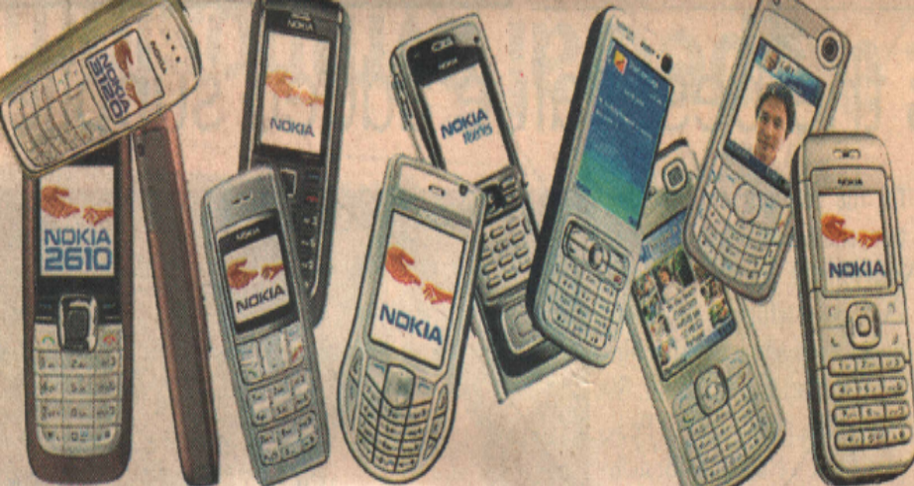

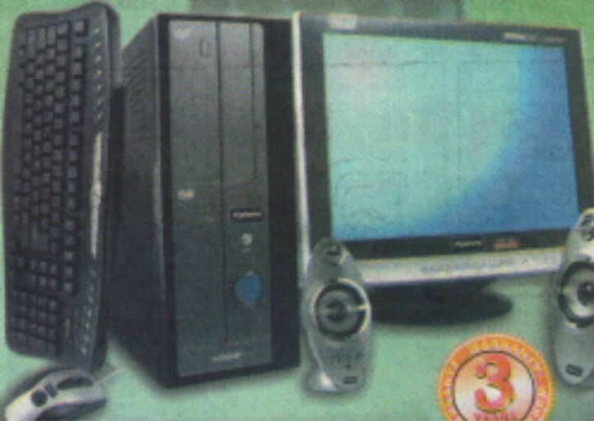
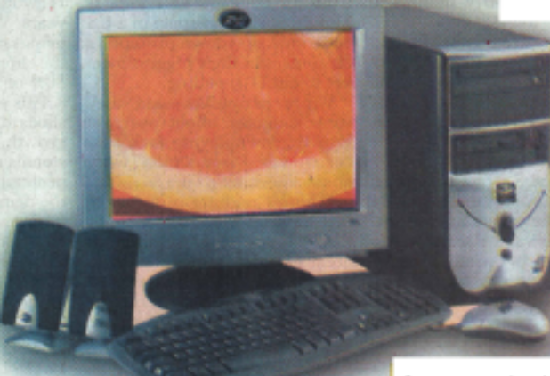
Computers

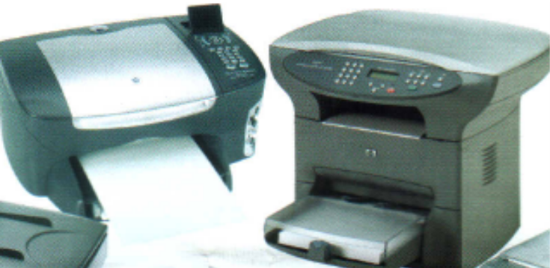
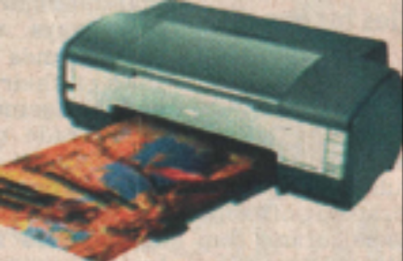
Printers

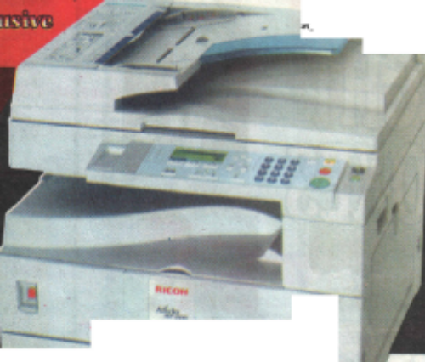
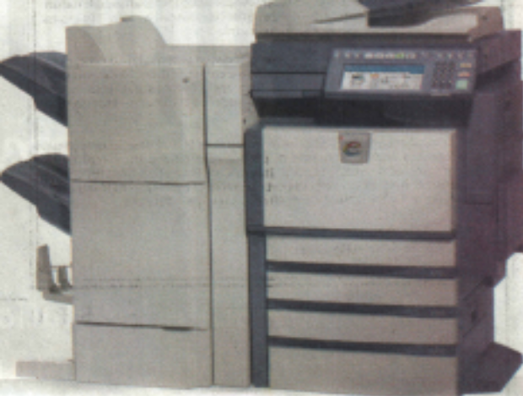
Photocopying Machines

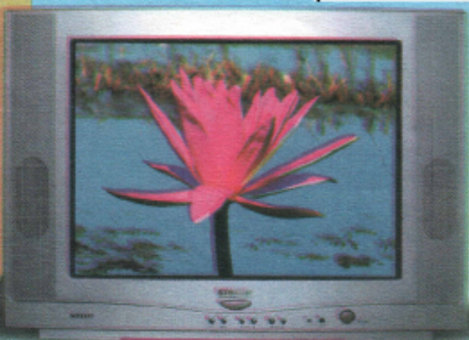
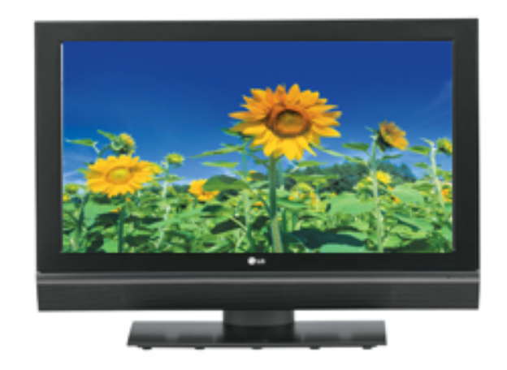
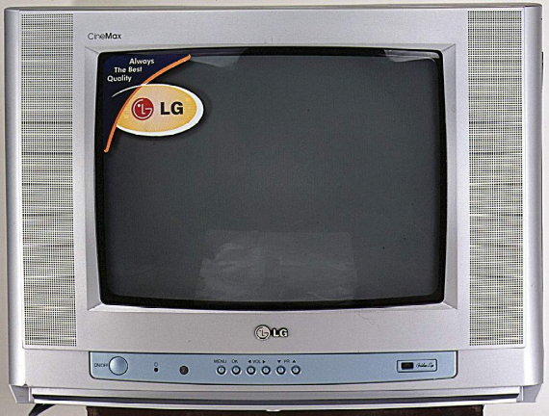

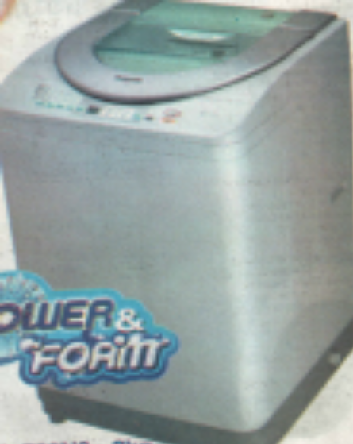
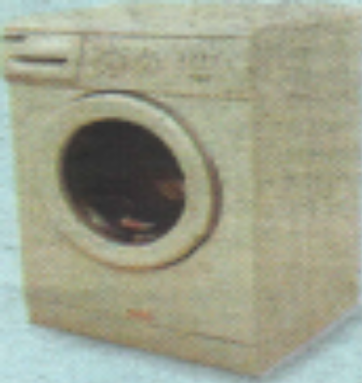
Washing Machines

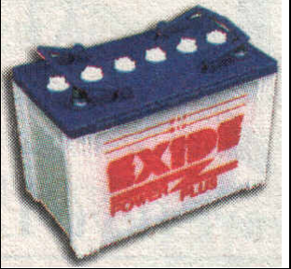
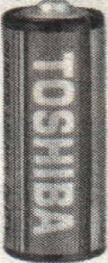
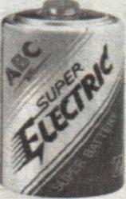
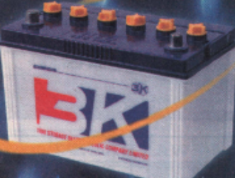
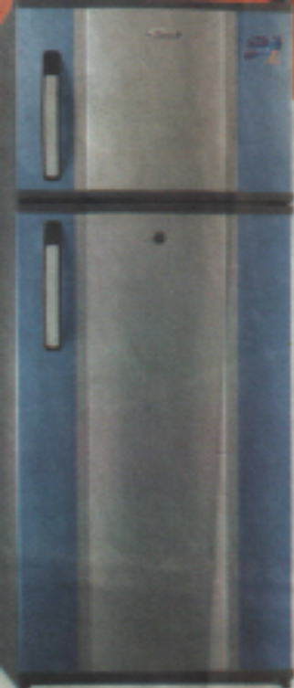
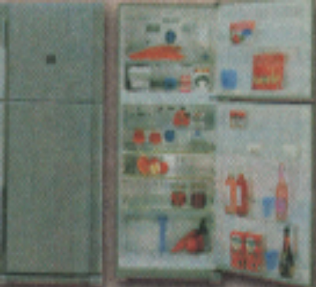
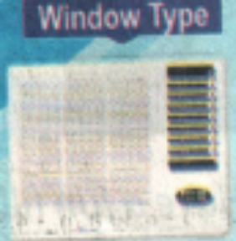
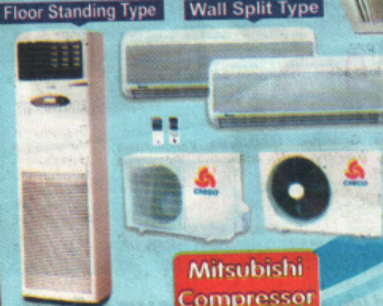
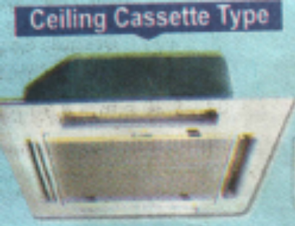
Batteries
Refrigerators
Air-Conditioners

Annex 05

Agenda for the final Stakeholder Workshop

Agenda
Development of a National Implementation Plan for E-Waste Management in Sri Lanka-Component I

Auditorium, Central Environmental Authority
26.02.2008

First Session

9.00 - 9.30 a.m. Registration

9.30 – 9.45 a.m. Welcome and objectives of the workshop
Secretary, MENR

9.45 -9.55 a.m. Address by the Chairman of CEA

9.55 -10.10 a.m. Introduction to E-Waste Management Project
Ms. L. P. Batuwitage, Director, MENR

10.10 - 10.20 a.m. Presentation of Methodology adopted for the Survey
Mr. Lal Fernando, Director, CEA

10.20 - 10.45 a.m. Tea

Second Session-Presentation of the draft Report

Facilitation – Prof. Ajith De Alwis
Mr. Nimal Perera

10.45 - 11.00 a.m. Presentation of the Draft Report-Desk Study-CEA

11.00 - 11.30 a.m. Discussion

11.30 - 11.45 a.m. Presentation of the Draft Report-Industrial and Commercial Sector-CEA

11.45 - 12.15 a.m. Discussion

12.15 - 1.00 p.m. Lunch

1.00 - 1.15 p.m. Presentation of the Draft Report-Household Sector-CEA

1.15 - 1.45 p.m. Discussion

1.45 - 2.00 p.m. Presentation of the Draft Report-Repair and Maintenance Sector-CEA

2.00 - 2.30 p.m. Discussion

2.30 – 3.45 p.m. Summing up and vote of Thank

3.45 – 4.00 p.m. Conclusion of Workshop followed by tea

Annex 06

Final Stakeholder Workshop Feedback Format

Development of a National Implementation Plan for E-Waste Management in Sri Lanka-Component I

Auditorium, Central Environmental Authority
26.02.2008

- Name :

- Organization:

- Position

- Tel: Fax: E-mail:

- Comments on Desk study related contents/coverage:

- Comments on Industrial and Commercial related contents/coverage:

- Comments on Household sector related contents/coverage:

- Comments on repair and maintenance sector related contents/coverage:

